|  |  |  |
| --- | --- | --- |
| **Philadelphia Federation of Teachers (PFT) Health & Welfare Fund** |  | |
| **Inspection Date: 12.16.2016**  **IEQ Related Investigation By:**  Jerry Roseman, PFT  **Others Present During the Inspection:**  Building Engineer – Mary Costello  Custodial Assisstent – Russell Dorr | **Some Relevant Building Details:**  • Year Built - 1948  • S.F [school] – 91,000  • S.F [site] – 564,969  • Current [as of 2012] FCI – 73% [reported by SDP]  76% [***calculated value***]  • 1200+ students  • 100% listed as “CEP Economically Disadvantaged”  • 100+ staff |
| **Solis Cohen Elementary School**  **IEQ Site Visit** | **Report Prepared by:** Jerry Roseman, MSc.IH.  Director of Environmental Science & Occupational Safety & Health -- PFTH&WF/U-H&S  **Date Report Issued**: 12.20.2016 | **Photos Attached: Yes** |
| **Building Address:** Tyson Avenue and Horrocks Street | | |

|  |
| --- |
| **Inspection Overview**  In response to a PFT union/staff request for an evaluation related to persistent heating system/steam leak problems at Solis Cohen ES, located at Tyson Avenue & Horrocks Street, an inspection was scheduled for Friday, 12.16.2016.  Upon receiving the assessment request [on 12/15], I contacted SDP-OEMS to schedule a joint evaluation of the the school; however, I was informed that earlier that same day [i.e. 12/15] OEMS had already conducted an evaluation without providing notification to us or including us in their 12/15 assessment.  On my arrival at Solis Cohen, the interim, acting Custodial Assistant, Russell Dorr, and the acting Building Engineer [B.E.], Mary Costello, accompanied me during the site inspection.  This inspection was a *limited scope evaluation* [LSE], and should therefore be considered as presenting only a “snap shot” of school conditions observed by us at the time of our evaluation – it was **not** intended to be a comprehensive or systematic assessment of all potential IEQ and related building condition problems that might potentially exist at Solis Cohen. It also closely followed up on the assessment conducted by Brian Joseph, SPD-OEMS consultant, a day earlier and OEMS findings and recommendations are included and referenced [explicitly in some cases] in this report.  The findings and recommendations provided below reflect inspection observations and information provided by school staff during our 12.16.2016 site visit, and on my review of outstanding inspection reports, evaluations and recommendations. The observations and recommendations provided herein should be combined with and supplemental to those included in the SDP-OEMS IEQ Dashboard and related reports, and should be incorporated in the OEMS IEQ Dashboard and forwarded to the Department of Facilities, Maintenance and Operations [FM&O] in order to ensure that a comprehensive list of needed remediation and response actions is developed to be acted upon. |
| |  |  |  | | --- | --- | --- | | **Issue & Location** | **Relevant Observations, Findings & Measurements** | **Comments-Recommendations-Informational Request** | | **Main Entrance & Office Hallway** | • Heating related deficiencies in the main entrance area [under-heated] and the Main Office Hallway [no operating heating system] are ongoing – measured temperatures were between 570F – 590F  • Ceiling mounted light fixture not fully secured.  All hallway windows have been covered with a film to prevent draft.  Light fixtures have been checked and do not present a hazard, a work request has been issued for aesthetic reasons.  Reference IEQ Dashboard- Recommendations were provided to seal the outdoor intakes in the A-Wing to prevent cold drafty air from entering the building since the heating was isolated in this section. | 1) Assess and repair the documented heating system problems.  2) Assess and repair hallway light fixture  2) FM&O should coordinate with and notify B.E., Principal and PFT building and PFTH&WF/U-H&S representatives about repair schedule details in order to facilitate effective site-specific planning, communication and remediation effectiveness, verification and accountability. | | **MOLD**  **Rooms 29, 30, & Boy’s Bathroom [F Wing] --** | • Mold was documented in each of these areas and “Mold DDC” issued on 12/15 by OEMS  • Water stained ceiling tiles were observed [reported on the OEMS IEQ Dashboard]  •1) Mold removal was completed at the time of my 12/16 visit,What was the cause The cause appeared to be related to steam leaks in the crawlspace below this room. Maintenance is presently working to address this issue.  2) Book Case removed. Cut and cap lines under floor, paint wall Lines are being cut and capped below floor 12/30/16, exterior water fountain being removed, repairs to wall / floor are being made 12/30/16. Painters scheduled for 1/3/17.  3) OEMS Dashboard;  4)Report for Principal  All water stained ceiling tiles have been replaced. | 1) Evaluate and characterize underlying condition[s] leading to mold growth and address.  2) Replace mold-damaged bookcases and other relevant finishes/fixtures that were removed.  3) Implement all recommended actions from the OEMS IEQ Dashboard dated 12.15.2016.  4) FM&O should coordinate with and notify B.E., Principal and PFT Building & PFTH&WF/U-H&S representatives about heating system, flooring & asbestos related repair schedule details in order to facilitate effective site-specific planning, communication and remediation effectiveness, verification and accountability. | | **Rooms 26, 27 & 28 [F Wing] & F-Wing Hallway** | • Water stained ceiling tiles were observed [reported on the OEMS IEQ Dashboard]   1. No underlying issues discovered on ceiling tile replacement, all tiles replaced and will be monitored Reported on IEQ Dashboard -In rooms 27, 29, and 30,, the source appeared to be related to condensation forming on the un-insulated roof drain. 2. FAC to meet with Principal | 1) Evaluate and characterize the underlying condition[s] leading to water staining of ceiling tiles and replace all water stained ceiling tiles  2) FM&O should coordinate with and notify B.E., Principal and PFT building and PFTH&WF/U-H&S representatives about repair schedule details in order to facilitate effective site-specific planning, communication and remediation effectiveness, verification and accountability. | | **Girl’s Bathroom [F-Wing]** | • Ongoing and currently active steam leak documented at radiator. Room temperature was 840F – [radiator uncovered/unprotected with exposed surface temperature of 1900F – **BURN HAZARD**   1. Steam Leak Completed 12/29/16 2. Cover Guard 3. 3) FAC to meet with Principal | 1) Assess and repair the steam leak at radiator valve [documented on the OEMS IEQ Dashboard]  2) Place a cover/guard over the radiator to protect from the burn hazard presented.  3) FM&O should coordinate with and notify B.E., Principal and PFT building and PFTH&WF/U-H&S representatives about repair schedule details in order to facilitate effective site-specific planning, communication and remediation effectiveness, verification and accountability. | | **Room 30 A** | • “Remediation” work [likely Mold related although uncertain because no information was provided or available] conducted without any notification provided – dust, dirt and debris was left on room surfaces & still present at the time of this inspections. Educational materials on wall had “overspray” & the teacher reported a “chemical odor” in room - Teacher is now being treated for respiratory symptoms   1. Description of Remediation A scope of work was issued to the Environmental Office that specified the description of remedial actions. This scope (DDC) was also issued to the PFT rep. 2. Room has been thoroughly cleaned | 1) IEQ-related remediation work should only be conducted following notification to/coordination with OEMS and notification to the B.E., Principal and PFT representative about repair schedule details should be provided in order to facilitate effective site-specific planning, communication and remediation effectiveness, verification and accountability.    2) A description of the remediation actions conducted should be provided.  3) Additional cleaning of surfaces throughout this room should be immediately conducted. | | **Staff Bathroom at**  **Front of Auditorium alongside stage** | • Dirty [yellowish/brown] water reported [and verified at the time of the inspection] from the sink in this bathroom   1. Water continues to be brownish in color on hot side only. OEMS to evaluate. 2. FAC to meet with Principal | 1) Assess the source of the discolored water in the bathroom sink and repair as required  2) FM&O should coordinate with and notify B.E., Principal and PFT building and PFTH&WF/U-H&S representatives about repair schedule details in order to facilitate effective site-specific planning, communication and remediation effectiveness, verification and accountability. | | **BUILDING WIDE ISSUE**  **F-Wing Classrooms Heating Problems** | • Classrooms significantly overheated and lack of Automatic Temperature Controls or other effective means of controlling temperatures exist throughout this area   1. Evaluation of work orders 2. Manual Control valves Reference the IEQ Dashboard - The F-Wing was overheated during the OEMS visit, the steam leaks in the crawlspace may be contributing to this condition. Manual control valves may be an option to provide some control over the heating system. 3. FAC will meet with Principal | 1) Immediately conduct a comprehensive evaluation of the heating & ATC systems and all components and review all outstanding work orders and make repairs as necessary to ensure occupant areas are properly heated.  2) Consideration should be given to immediately installing manual control valves as in interim measure to provide occupant control of heat.  3) FM&O should coordinate with and notify B.E., Principal and PFT building and PFTH&WF/U-H&S representatives about repair schedule details in order to facilitate effective site-specific planning, communication and remediation effectiveness, verification and accountability. | | **BUILDING WIDE ISSUE**  **Crawl Spaces – B-Wing & F-Wing - Steam Leaks** | • Steam leaks are present in the crawl spaces under both of these building wings and classrooms resulting in heating and related problems and impacts   1. Evaluation of steam leaks 3 of 5 steam leaks have been repaired, in crawlspace F-wing remaining will be complete 12/30/16. 2. FAC to meet with Principal | 1) Conduct an evaluation of steam leaks and related conditions associated with the heating system components in the crawl space and effect repairs as required  2) FM&O should coordinate with and notify B.E., Principal. PFT Building Representative and PFTH&WF/U-H&S representatives about repair schedule details in order to help timely response and to facilitate effective site-specific planning, communication and remediation effectiveness, verification and accountability. | | **BUILDING WIDE ISSUE**  **A-Wing – Heating Problem** | • Hallway areas are extremely cold resulting in untempered air infiltrating classrooms causing cold, drafty conditions -- many classrooms are overheated   1. Repairs to hallway heating Ordered modine heaters, (not received) wiring for heaters complete. 2. FAC to meet with Principal | 1) Evaluate the source of this condition [some details provided in the OEMS IEQ Dashboard and effect repairs as required.  2) FM&O should coordinate with and notify B.E., Principal. PFT Building Representative and PFTH&WF/U-H&S representatives about repair schedule details in order to help timely response and to facilitate effective site-specific planning, communication and remediation effectiveness, verification and accountability. | | **BUILDING WIDE ISSUE**  **Lack of Information** | • Consistent, systematic procedures to ensure that notification is provided to the school B.E., Principal and the PFT Building Representative about SDP environmental and facility related inspection observations, findings and recommendations and about remediation work scope and schedules **are not in place** thereby compromising effective site-specific planning, communication and remediation effectiveness, verification and accountability.   1. Operations to meet with Principal | 1) Develop and implement systematic and compliant procedures to **always ensure** District FM&O, Capital and/or OEMS notification to the school B.E., Principal and PFT and PFTH&WF/U-H&S representatives about evaluation activity, timing and scope.  2) Routinely provide copies of IEQ Dashboards, DDCs, Work Order summaries/schedules and other IEQ-deficient building related response and remediation information to the school B.E., Principal and PFT Building and PFTH&WF/U-H&S representatives in order to facilitate effective site-specific planning, communication and remediation effectiveness, verification and accountability. | |

**Site Visit Photographs**

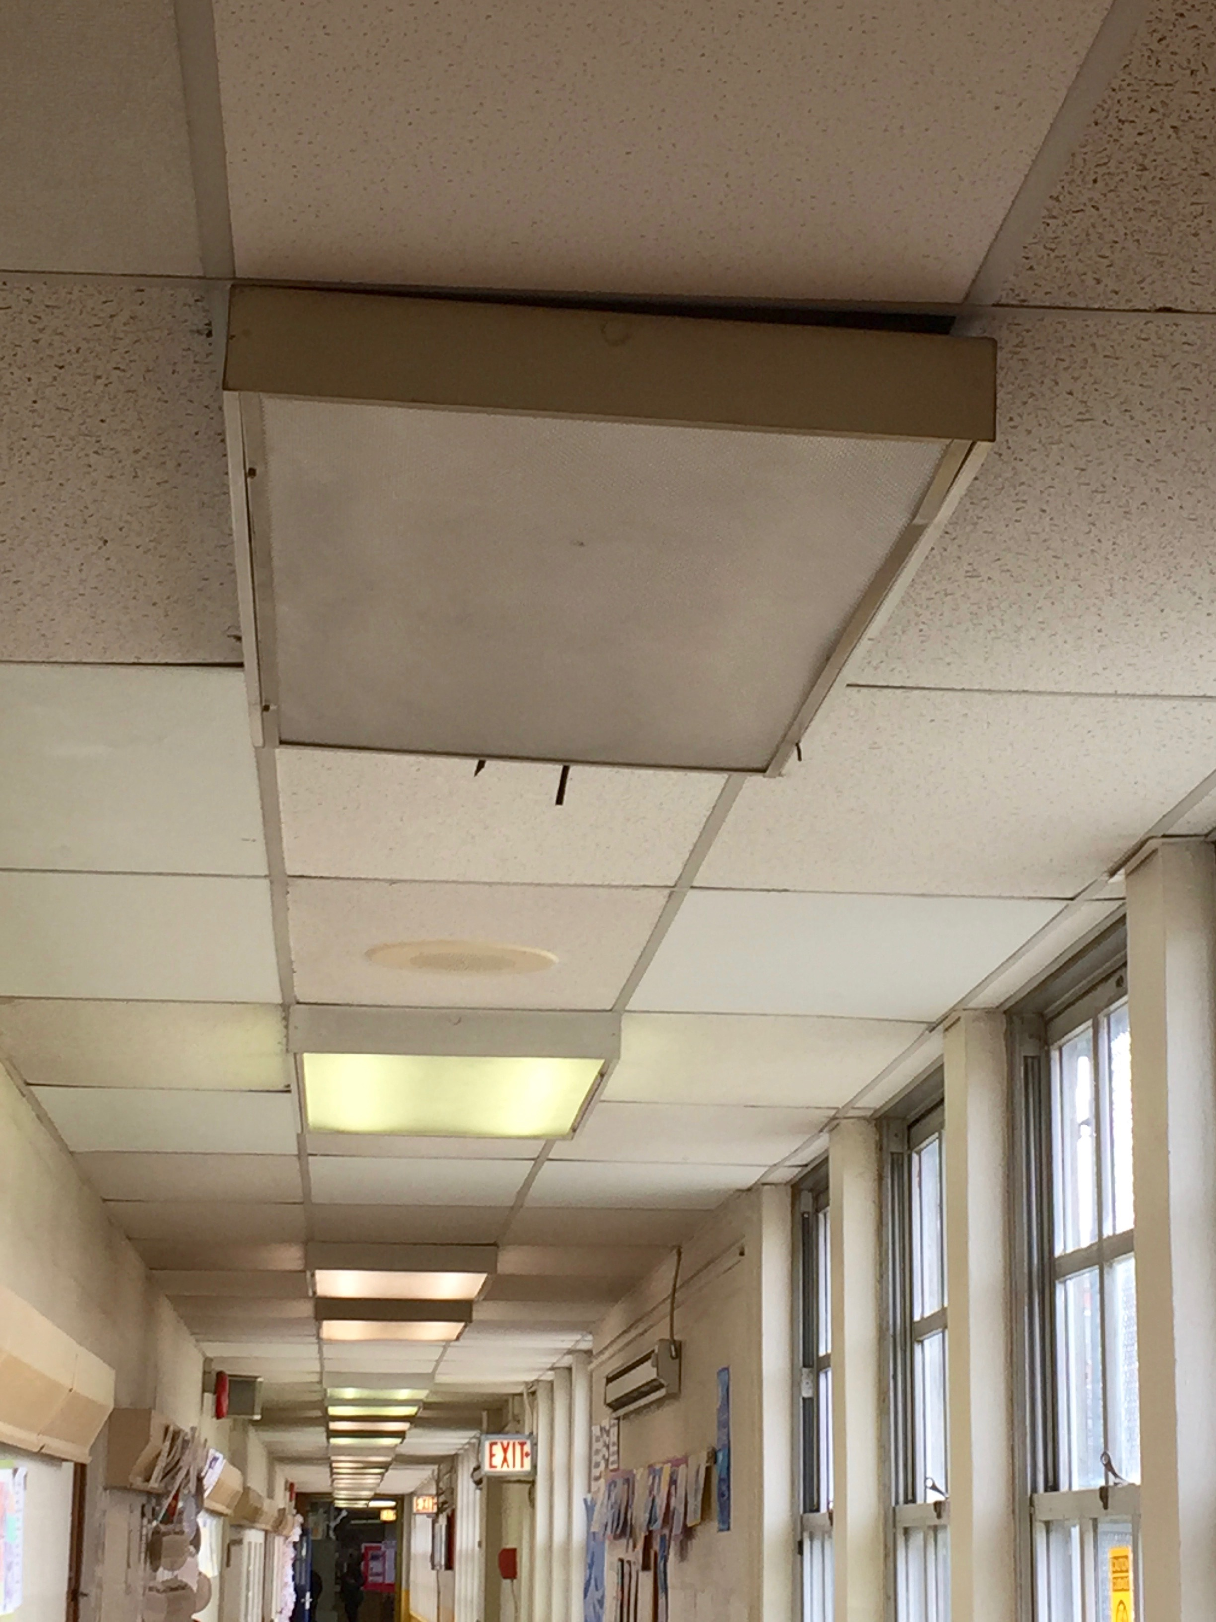

**Photo 1 – Solis Cohen ES - 12.16.2016 – Main Office Hallway – Ceiling Mounted Light Fixture – Not Fully Secured**

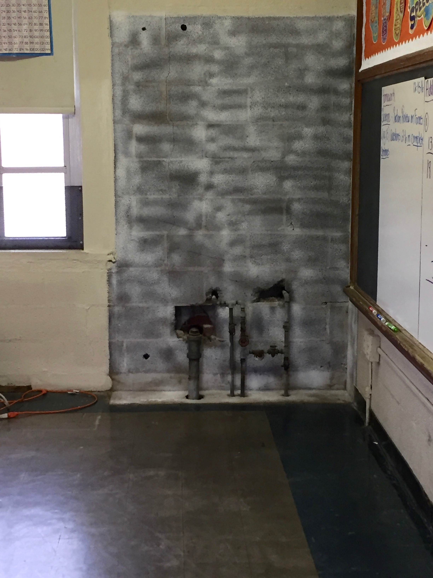

**Photo 2 - Solis Cohen ES - 12.16.2016 – Room 29 – Condition after mold remediation and removal of impacted bookcase**

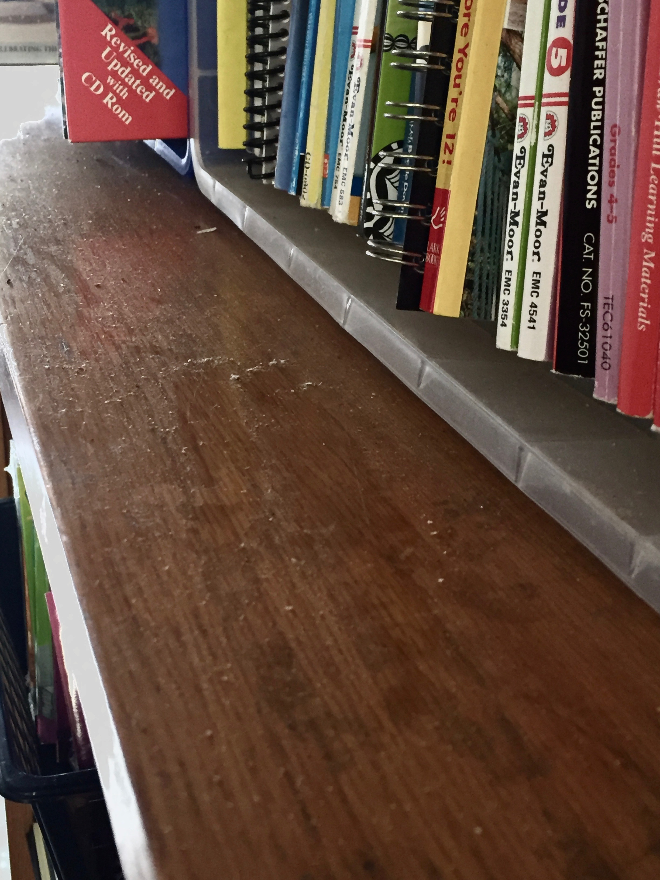

**Photo 3 - Solis Cohen ES - 12.16.2016 – Room 30A – Dust/Dirt/Debris on surfaces – not properly cleaned following remediation**